INTRO:  
GENESIS is the annual robotic hands-on WORKSHOP   
conducted exclusively for the freshmen students enthusiastic to seek the adventure of inducing life   
to machines.  
Genesis 17 gave an insignht on how to build an autonomous light guided retriever and carrier bot.  
The workshop involved theory sessions on robotics and a practical session on bot-building.  
The workshop requiring no prior experience in robotics was conducted for aspirants cutting across all   
departments.  
  
Topics:  
1) Mechanics - Gears, Servo Mechanism, Inverse Kinematics, Linkages and Four-Bar Mechanism.  
2) Electronics - Micro controller peripherals (Timers and PWM, ADC, Interrupts, Serial Communication), Voltage Regulator, Motor Drivers and other components.  
3) Programming - Embedded C.  
4) Fabrication  
  
*Take away Kit*  
1. Arduino microcontroller  
2. DC and Servo motors  
3. Gears  
4. Robot chassis   
5. Proximity sensor and light dependent resistors  
6. Wire Stripper, Screwdriver  
7. Multimeter and many more.

RMI Week

RMI Week aspires to be the embodiment of the work, innovation and research that happens at NITT’s the premier robotics club. We want you to have a sneak peek into the world of robotics, learn about what goes into developing and building a robot, and to kindle a sense of interest and curiosity. We guarantee that you will have fun. Be there!

RMI WEEK ‘17

Seven days of events, lectures, hackathons and a lot more, RMI Week ‘17 will be the first ever edition of its kind at NIT Trichy.

This is a brief on the line up for RMI Week:

• Following ’17 – The annual robotics competition for the first years.

• Lectures – A total of 4 lectures on various domains in Robotics.

• Events – Online activities, quizzes, and many more.

• OpenSAC- 05 – Get a chance to visit our workplace and see our projects.

• Hackathon – Work for 8 straight hours to get a problem statement done.

PS:

1. Following is exclusively for the first years.

2. Hackathon is for the first years (who get shortlisted from Following ’17) and second years (those who are participating in lateral inductions).

3. Apart from Following and Hackathon, all others i.e. Lectures, events and OpenSAC – 05 is open to the whole college to participate.

Following ’17

Conducted as part of RMI Week, it is the flagship event of RMI, for freshmen to rewire their brains and bots to test their skills. A line follower competition, with a twist, and a lot of fun, sums up what ‘Following’ delivers year after year. Watch as freshmen battle for glory, and rack up points, as they conquer the track. Special prizes are also given for those with best designs, new innovations, fabrication skills and more. This year’s theme is “Star Wars”. Read the problem statement for more information​.

ROBOVIGYAN

### **RoboVision:**

Robovision is a completely autonomous robotics event with image processing for feedback conducted by RMI during Pragyan. The aim of the event is to program the robot to loot the exact amount of treasure from the treasure chests (coloured shapes drawn on the arena) as mentioned at the start of each game. The treasure chests are given loot values depending on the color and the shape. This event tests the image processing, control and algorithms of the participants. The event sees participation of a lot of teams from various colleges across South India.

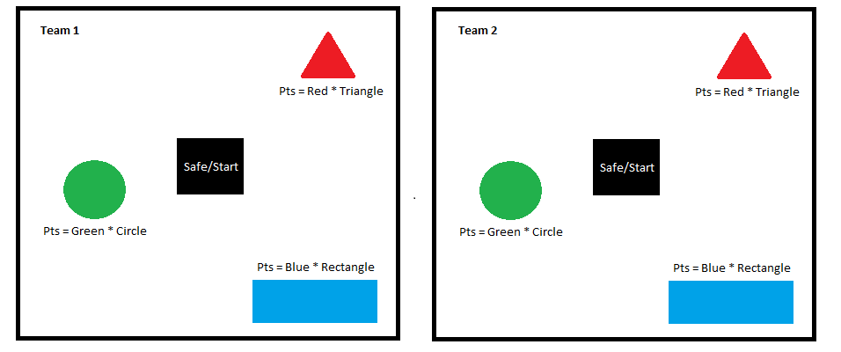

**Seven Stones**

Seven Stones, a traditional South Indian game played between two teams in a bounded area involving a ball and a pile of flat stones. This event conducted by RMI during Pragyan, gives participants an opportunity to play the traditional game like an engineer. A member of one team (ATTACKERS) throws a soft ball at a pile of stones to knock them over. Now, the members of the other team, the STACKERS try to restore the pile of stones while the opposing team, the “Attackers”, try to stop them by throwing a ball at them. If the ball touches any one of the “Stackers”, he is no longer a part of the game and his team continues without him. Participants from various educational institutions pool in every year and contribute to the success of the event.